**SENSOR TECHNOLOGY LAB 220202**

**EXPERIMENT - 1**

SUBMITTED BY: ASMITA JAIN

0901EO201017

**AIM:** To draw the characteristic of RTD (resistance temperature detector.

**THEORY:**

An RTD works by using a basic principle; as the temperature of a metal increases, so does the resistance to the flow of electricity. An electrical current is passed through the sensor, the resistance element is used to measure the resistance of the current being passed through it.

Commonly used RTD Materials:

• Platinum (most popular and accurate)

• Nickel

• Copper

• Balco

• Tungsten

Temperature calculations:

RTDs are manufactured from metals whose resistance increases with temperature. Within a limited temperature range, its resistance increases linearly with temperature:

**Rt = R0[1+ α (t-t0)]**

Where:

Rt = resistance at temperature 't'

R0 = resistance at a reference temperature ( Generally 0 degree C)

α = temperature coefficient of resistance (°C‾1)

**DIAGRAM:**

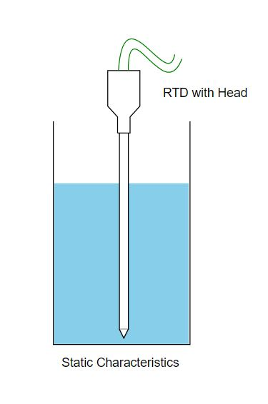

**OBSERVATION:**

1. MATERIAL: Platinum

Temperature coefficient: 0.00385

|  |  |  |
| --- | --- | --- |
| **R0** | **∆T** | **Rt** |
| 100 | -99 | 61.885 |
| 100 | -192 | 26.08 |
| 100 | 391 | 250.535 |

1. MATERIAL: Copper

Temperature coefficient: 0.00427

|  |  |  |
| --- | --- | --- |
| **R0** | **∆T** | **Rt** |
| 100 | 55 | 123.485 |
| 100 | 72 | 130.744 |
| 100 | 190 | 181.13 |

**GRAPH:**

**I)**

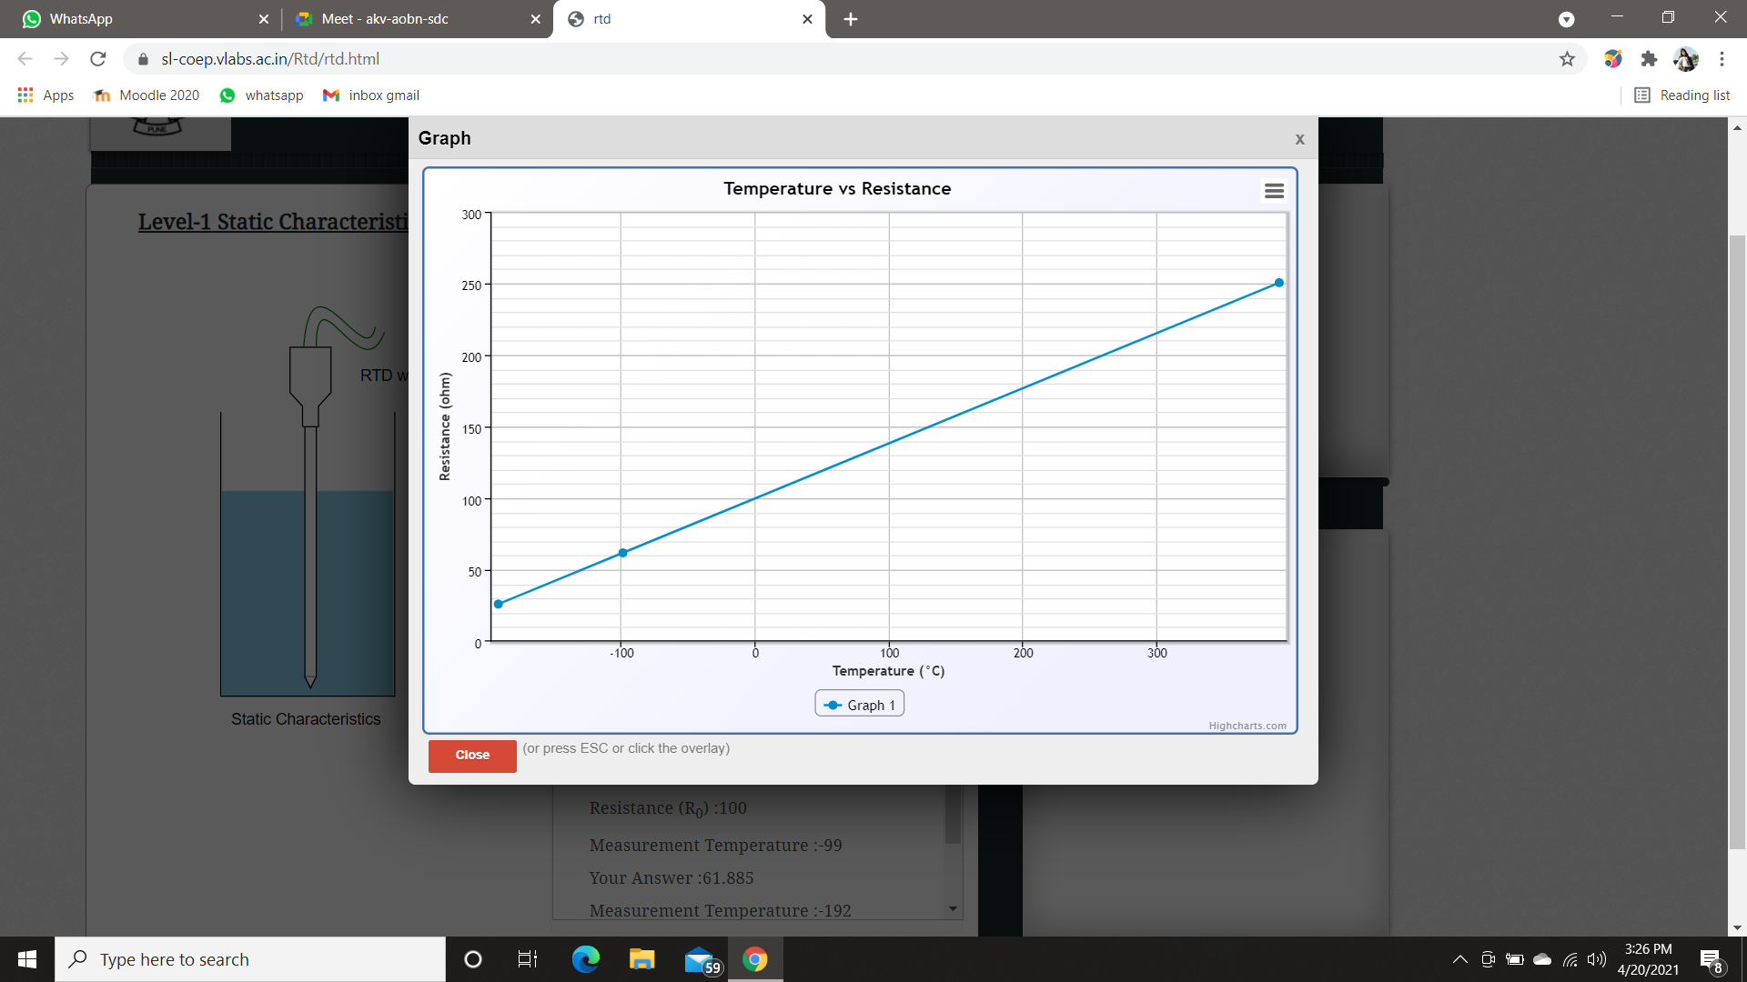

**II)**

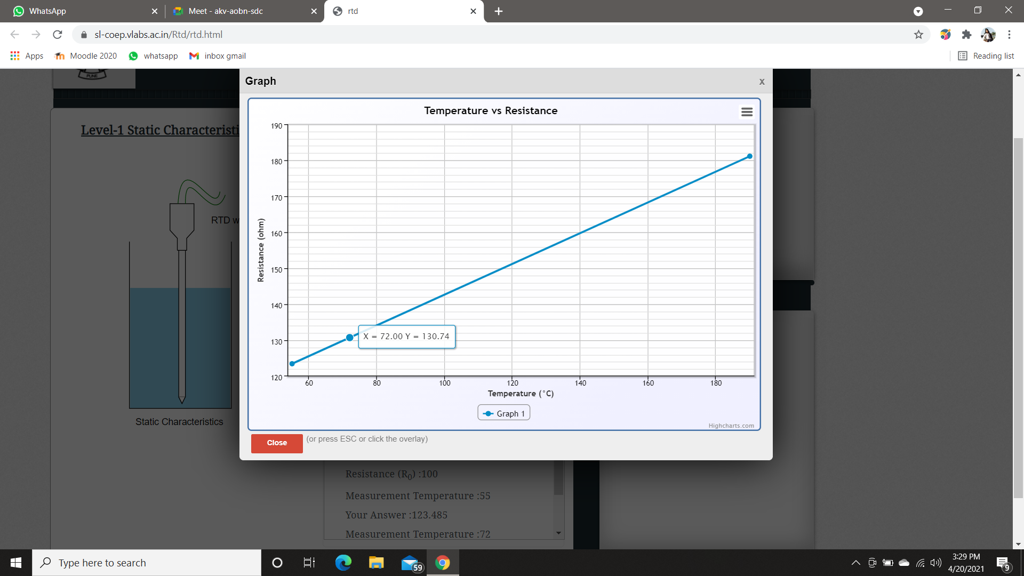

**RESULT:**

Hence , we have studied about RTD and its characteristics.